Orion Re-Training Pipeline TDD

Architecture Diagram:
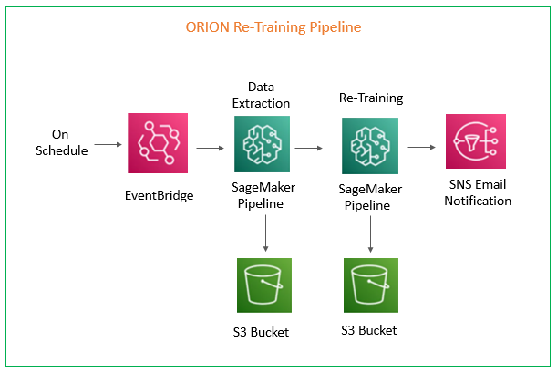
Description:
- Event Bridge triggers this pipeline (Every month 18th at 03:00 AM EST). Then it invokes a dedicated step function which orchestrates all the other steps sequentially.
- There are two sagemaker pipelines used in this workflow, one for Data Extraction followed by other for Re-Training. The outputs for these pipelines are stored in s3 bucket.
- Once all this process is completed SNS Email Notifications are sent, if the workflow is success or failure

Sagemaker Pipelines:
Orion Data Extraction Pipeline:
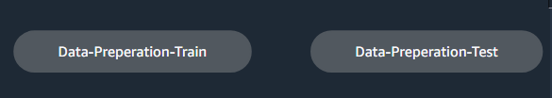

Orion Re-Training Pipeline:
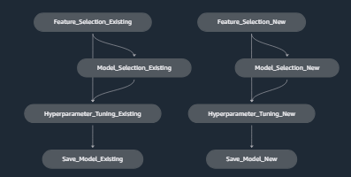

AWS Services:
AWS Services Used | Name
Evenbridge Rule | Orion_Re-Training
Step Function | sagemaker-naf-orion-retraining
Sagemaker Pipeline | orion-training-data-extraction, orion-training-dev
SNS Topic | sagemaker-naf-orion
Orion Data Extraction Pipeline s3 locations:
AWS Service | Input/Outputs | Paths
s3 | Inputs | s3://sagemaker-orion-dev/training/inputs/model-artifacts/
s3 | Outputs | s3://sagemaker-orion-dev/training/outputs/data-prep/
s3 | Outputs | s3://sagemaker-orion-dev/testing/outputs/data-prep/
s3 | paths | s3://sagemaker-orion-dev/paths/data_extraction_paths.json

Orion Re-Training Pipeline S3 locations:
AWS Resource | Steps | Inputs/Outputs | Type/Condition | Paths
s3 | Feature Selection | Outputs | New/Existing | s3://sagemaker-orion-dev/feature_selection/
s3 | Model Selection | Outputs | New/Existing | s3://sagemaker-orion-dev/model_selection/
s3 | Hyperparameter Tuning | Outputs | New | s3://sagemaker-orion-dev/hyperparameter_tuning/outputs_new/
s3 | Hyperparameter Tuning | Outputs | Existing | s3://sagemaker-orion-dev/hyperparameter_tuning/outputs_existing/
s3 | Save Models | Outputs | Only if Threshold is satisfied | s3://sagemaker-orion-dev/models/Current_Model_Outputs/
s3 | Save Models | Outputs | New/Existing | s3://sagemaker-orion-dev/models/Retrained_Model_Outputs/
s3 | paths |  |  | s3://sagemaker-orion-dev/paths/data_retraining_paths.json

Data Extraction Parameters:
Parameters | Values
max_week | Take from query
Train churn_cut_off_week | max_week - 25 weeks
Train Current_week | max_week - 46 weeks
Train Offset | 8
Train Randomization | TRUE
Test churn_cut_off_week | max_week - 8 weeks
Test Current_week | max_week - 38 weeks
Test Offset | 0
Test Randomization | FALSE
last_trx_cut_off_week(Test) | current_week - 9 weeks

Thresholds:
Customers | Recall | Precision | F1 Score | Precision@500 | Precision@2000 | 13 Weeks(recall%) | FP
New | 0.6 | 0.45 | 0.51 | 0.55 | 0.5 | 60 | <1400
Existing | 0.6 | 0.2 | 0.3 | 0.65 | 0.55 | 65 | <25000

